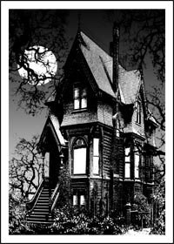
Gothic Story Assignment
Working in your assigned group, you are to create a collection of American Gothic Short Stories. Each person in your group will write one short story (1 ½ page minimum). As a group, you will create a book jacket (cover) for your collection of short stories.
Using everything we’ve learned from Edgar Allen Poe’s “The Raven” and “The Fall of the House of Usher,” as well as our discussion about “Elements of American Gothic” and the “How to Read a Short Story” handout, you will write an American Gothic short story that follows the guidelines below:
Story Guidelines
- One and a half pages minimum length
- Uses at least two images/devices from “Chart 1” on back of this sheet.
- Uses language from “Chart 2” on back of this sheet. Five words minimum, each word underlined.
- Have a clearly defined plot, characters, conflict and resolution.
Book Jacket Guidelines
- Title clearly displayed, creative, visual
- Images used to make cover attractive
- Well designed to hold stories
How you are graded
- Individual grade for story (40 points)
- Group grade for cover (10 points each group member, graded as whole group)
It should go without saying, but I’m going to be very explicit – your story must be school appropriate. That means no inappropriate language and no extreme violence. This is not a violent horror story; this is an American Gothic story. There is a difference. The focus is more on building tension than on decapitations and foul language. If you don’t understand the difference, talk to me.

Mystery | diabolical, enchantment, ghost, goblins, haunted, infernal, magic, magician, miracle, necromancer, omens, ominous, portent, preternatural, prodigy, prophecy, secret, sorcerer, spectre, spirits, strangeness, talisman, vision
Fear, Terror, or Sorrow | afflicted, affliction, agony, anguish, apprehensions, apprehensive, commiseration, concern, despair, dismal, dismay, dread, dreaded, dreading, fearing, frantic, fright, frightened, grief, hopeless, horrid, horror, lamentable, melancholy, miserable, mournfully, panic, sadly, scared, shrieks, sorrow, sympathy, tears, terrible, terrified, terror, unhappy, wretched
Surprise | alarm, amazement, astonished, astonishment, shocking, staring, surprise, surprised, thunderstruck, wonder
Haste | anxious, breathless, flight, frantic, hastened, hastily, impatience, impatient, impatiently, impetuosity, precipitately, running, sudden, suddenly
Anger | anger, angrily, choler, enraged, furious, fury, incense, incensed, provoked, rage, raving, resentment, temper, wrath, wrathful, wrathfully
Largeness | enormous, gigantic, giant, large, tremendous, vast
(Above) Chart 1: Imagery and devices used in American Gothic Literature
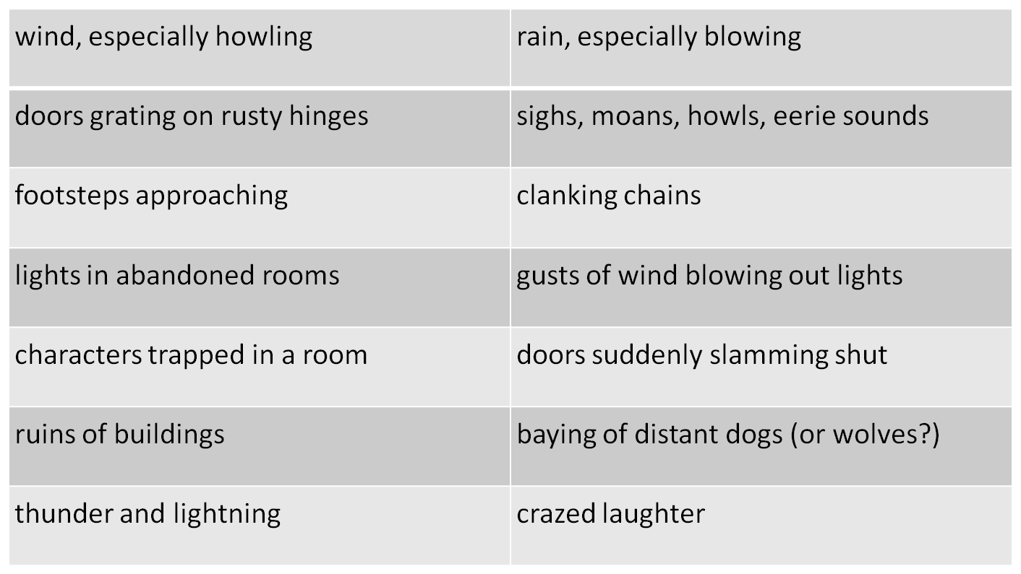
(Below) Chart 2: The language of American Gothic Literature

